Utilizing Automation To Maximize Performance at the City of Lebanon Authority Wastewater Treatment Plant

Steven Kestel^{1*}, Gregory J. Duffy¹, Frank DiScuillo²
1. BioChem Technology, Inc.
2. City of Lebanon Water Authority
*Email: Skestel@biochemtech.com

ABSTRACT

Rerating and upgrading an existing treatment process within a tightly limited area requires both design and operational ingenuity. This paper details how one such innovative control strategy is used to achieve maximum operational flexibility and energy efficiency from an Integrated Fixed Film Activated Sludge (IFAS) process with automated anoxic/aerobic swing zones located both before and after the IFAS zones at the City of Lebanon Authority Wastewater Treatment Plant. The process optimization control system focuses primarily on maintaining effluent nitrogen goals and achieving process stability and energy efficiency. To accomplish this, the system continuously monitors the process ammonia and nitrate readings in an effort to qualify influent strength, sets zone specific dissolved oxygen (DO) setpoints to modify each zone’s reaction rate, changes the internal mixed liquor recycle rate (IMLR) to maximize anoxic nitrate treatment, brings swing zones in to and out of aerobic operation in order to supply treatment on demand as the process requires, and controls a bypass valve/flow for the upstream trickling filter which allows for the system to increase or decrease the total available carbon for denitrification in the pre-anoxic zones. Use of the system has allowed the plant to efficiently meet its permit requirements while maximizing the performance of its process.

KEYWORDS: Swing Zones, IFAS, Energy Savings, Nitrogen Control.

INTRODUCTION

The City of Lebanon Authority (COLA) Wastewater Treatment Plant (WWTP), located in Lebanon, Pennsylvania, was upgraded in 2012 to meet the requirements of a new discharge permit. The plant discharges into the Chesapeake Bay, and as part of its new permit, the plant is limited to a total maximum daily load (TMDL) discharge of 66,224 kg (146,000 pounds) of nitrogen per year. At the current average daily flow rate of 22,712 m³/day (6 million gallons per day (mgd)), this equates to an effluent total nitrogen concentration of 8.0 mg/L. Major unit processes at the plant include primary clarifiers, trickling filters, intermediate clarifiers, secondary treatment, secondary clarifiers, a denitrification filter, and UV disinfection before discharge. An overview of the plant is shown in Figure 1.

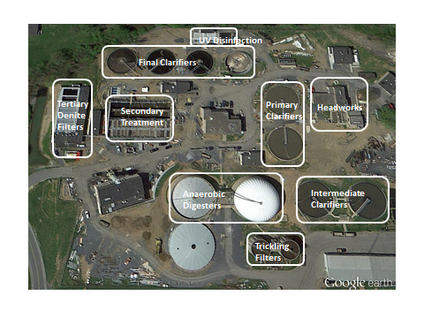
Figure 1: Major Unit Processes
The plant had little available space for expansion, which meant that a space efficient treatment process had to be utilized in the upgrade. For this reason, an Integrated Fixed Film Activated Sludge (IFAS) process was chosen for secondary treatment. Swing zones that can be switched between anoxic or aerobic operation were incorporated before and after the IFAS zones to enhance denitrification or nitrification as required by process conditions. The existing trickling filters were kept for BOD removal, with a bypass installed to provide carbon for denitrification in the pre-anoxic zone(s) of the secondary treatment process.

A diagram of the secondary treatment process consisting of 4 trains, each with three IFAS zones and two swing zones, one before the IFAS zones and one after, is depicted in Figure 2.

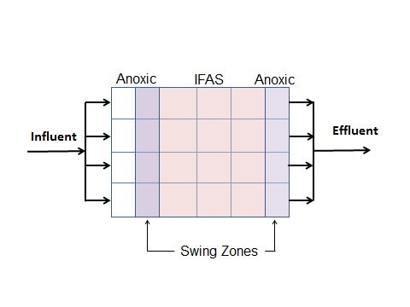
Figure 2: Secondary Treatment Diagram

The use of a trickling filter combined with an IFAS process while trying to minimize the effluent total nitrogen (TN) within a limited footprint presented several operational challenges. Specific challenges included balancing pressure in the aeration system with coarse bubble diffusers in the IFAS zones and fine bubble diffusers in the swing zones on the same air header, determining in real time the optimal state of each swing zone, and determining the trickling filter bypass rate.

DESIGN APPROACH

An advanced process control system was required to optimally overcome the challenges presented by the process and effluent requirements. The process control system need to perform multiple functions:

1. Switching the swing zones between anoxic or aerobic operation based on influent conditions
2. Determining the optimal dissolved oxygen (DO) set point in each aerated zone in real time to achieve required treatment levels
3. Maintaining the measured DO concentrations at their set point in each aerated zone
4. Controlling airflow in each aerated zone to satisfy the oxygen demand by modulating the air control valves
5. Controlling the blowers to meet the total airflow demand
6. Minimizing the system pressure in the air header by using a most open valve control strategy
7. Controlling the internal nitrate recycle flow rate to maximize denitrification
8. Controlling the trickling filter bypass flow rate to increase or decrease the available carbon for denitrification

Control systems that are capable of meeting Functions 2,3,4,5, and 7 have been demonstrated in numerous wastewater treatment plants to be effective at reducing energy use (Amand, Kestel, Leber, Liu, Rieger, and Shi). Automatic variation of swing zones, control of an aeration system with both fine and course bubble diffusers, and the control of the trickling filter bypass required the development of new control strategies.

A process flow diagram of one of the four IFAS trains, including the required instrumentation for the control system, is shown in Figure 3. Each swing zone and IFAS zone required an airflow meter and DO meter for DO control. Ammonia and nitrate meters were installed in two of the four trains in the swing zones. This allowed one of the four trains to act as a control train, and one train to act as a back-up should the control train have an instrumentation failure.

The architecture of the full control system is shown in Figure 4. All instrumentation was landed in a centralized control cabinet. The control system would calculate optimal values for each controlled subsystem, then either control such equipment directly, or send an electronic signal to other hardware that would implement the calculated setpoints.

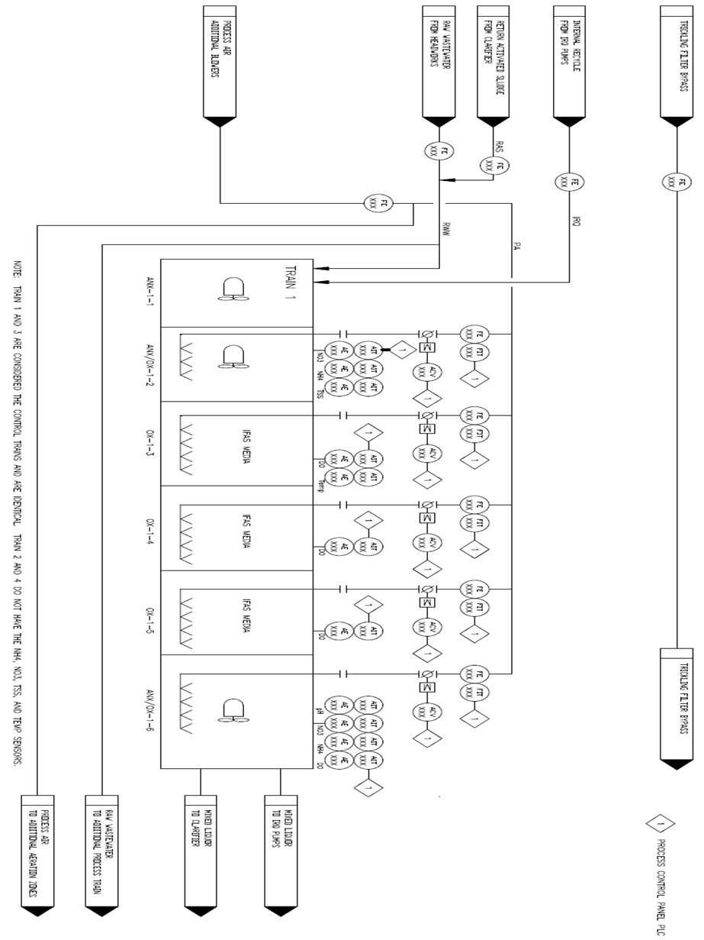
Figure 3: Process Flow Diagram
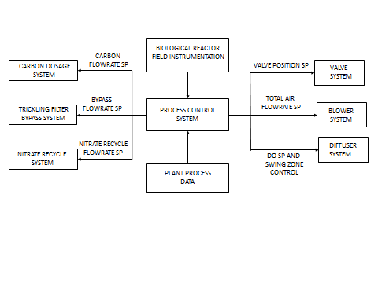
Figure 4: Control System Architecture
Swing Zone Control
Pre and post anoxic swing zones were incorporated into the process design to give plant operators the flexibility to control the amount of nitrification and denitrification. A simple operation strategy would be to always operate the swing zones in the aerobic mode, maximizing nitrification, and utilizing the tertiary denitrification filters to perform the required amount of nitrate removal. Such a mode of operation would have several drawbacks. First, aeration energy would be wasted by aerating the swing zones during periods when the swing zone volume was not needed to complete nitrification. Second, methanol costs would be increased to treat higher nitrate loads in the tertiary denitrification filters. Third, the air pressure in the header is increased when the swing zones are in an aerobic mode due to the use of fine bubble diffusers in the swing zones compared to coarse bubble diffusers in the IFAS zones. Fourth, less alkalinity would be regenerated under anoxic conditions, increasing the amount of chemical dosing required to maintain an appropriate alkalinity level.

The control system determines the optimal swing zone mode based upon the real time nitrification loading by using a feed-forward control algorithm. Incorporated into the feed-forward control algorithm is a biological simulation based upon the Activated Sludge Model #1 (ASM1) mathematical model that was customized to the plant specific process. This model incorporates both the biological and hydraulic characteristics of the process. The model is used in an iterative method to determine the effect the swing zone modes will have on the effluent ammonia concentration.

The simulation calculates an ammonia concentration profile throughout the bioreactor in the past, present, and future. An ammonia analyzer located in the first swing zone provides the control system with the ammonia concentration entering the IFAS stages. In addition to influent ammonia concentration, the model requires the following online plant data: influent flow, return activated sludge (RAS) flow, internal mixed liquor recycle flow rates, MLSS concentration, and temperature. The biological simulation also uses the maximum specific ammonia removal rate and DO half saturation constants for the suspended and biofilm biomass. The maximum specific ammonia removal rate, and DO half saturation constants were measured during initial startup of the process.

An effluent ammonia analyzer and DO meters are used to check the accuracy of the simulation. The feed-forward algorithm can automatically update model parameters if significant deviation occurs between the model predictions and the measured effluent ammonia.

The swing zones are set to an aerobic state whenever process simulation calculates that the IFAS media zones have insufficient nitrification capacity to meet the effluent ammonia target. Otherwise, the swing zones are set to an anoxic state to take advantage of the benefits described above.

Operators also have the option of running the system in a feed-back control mode, where the system sets the swing zone to aerobic when the effluent ammonia is above the target and to anoxic when the effluent ammonia is below the target.

Aeration Header Pressure Control
The control system opens and closes air control valves to distribute the air to the control zones according to the calculated needs of the respective zones. It uses a dynamic most-open-valve (MOV) logic so that the blowers always operate at the lowest possible system pressure, which minimizes aeration energy. When the swing zones are aerated, the MOV is one of the swing zones, because these zones, with fine bubble diffusion, have a higher airflow restriction than the IFAS zones with their coarse bubble diffusers. When the swing zones are not aerated, their valves will close and the MOV will move to one of the IFAS zones. At the same time, the system pressure will drop from about 7.55 psi with aerated swing zones to about 6.75 psi when only the IFAS zones are aerated. This requires that the transition conditions be well managed to prevent pressure oscillations and resulting instability. The interaction between the separate blower master control panel and control system was design to achieve this without disturbances.

Compared to a traditional, fixed pressure control scheme, the dynamic MOV control saves a significant amount of blower energy. If a fixed pressure scheme was utilized, the pressure would always have to be above the pressure required by the fine bubble diffusers, even when the swing zones are in an anoxic state. This wastes energy by requiring the blowers to consume more motor power to produce the same amount of flow, as calculated by using the fan laws for constant diameter impeller fans:

Q₁/Q₂ = (RPM₁/RPM₂) (1)

P₁/P₂ = (RPM₁/RPM₂)² (2)

PWR₁/PWR₂ = (RPM₁/RPM₂)³ (3)

Where,
Q = flow, m³/hr or SCFM
RPM = rotations per minute
P = Pressure (kPA or psi)
PWR = Power (kw or HP)

At equal flow, Q₁ = Q₂, P₁ = 7.55 psi, P₂ = 6.75 psi, and PWR₂/PWR₁ = (6.75/7.55)^{3/2}= 0.845.

Hence, at the lower pressure the blowers are drawing 84.5% of the power required at high pressure power, a savings of 15.5%, while supplying the same amount of airflow. This can add up to significant cost and energy savings over the life of the plant.

Trickling Filter Bypass Control
The trickling filter bypass control works with the internal mixed liquor recycle (IMLR) flow rate control to improve denitrification performance and total nitrogen removal. The amount of nitrate removed within the pre-anoxic stages is based upon the limitation of one of the following: nitrate loading, carbon loading, and contact time. The purpose of IMLR and primary effluent shunt control is to recycle enough nitrates and supply enough carbon to the anoxic stage so that the denitrification reaction takes place in a well-controlled nitrate and carbon concentration region, thus maximizing the reaction rate and TN removal. The IMLR rate is used to control the nitrate load, while the trickling filter bypass rate is used to control the carbon load. The goal of trickling filter bypass rate control is to supply just enough carbon such that the pre-anoxic zones are not carbon limited. This maximizes the denitrification in the pre-anoxic zones while preventing any excess carbon from entering the IFAS zones. Excess carbon in the IFAS zones could lead to the growth of heterotrophic bacteria on the IFAS media, reducing the amount of autotrophic bacteria growth and hence lowering the nitrification capacity of the IFAS media.

Nitrate analyzers located in the swing zones provide the control system with the nitrate loading entering and leaving the anoxic volume. The IMLR flow rate is increased when the nitrate in Stage 2 is below the target nitrate value, and is decreased when the nitrate is above the target value. When IMLR reaches maximum flow rate the trickling filter bypass flow will decrease in flow if nitrate is below target value, and the trickling filter bypass flow will increase flow when the IMLR is at minimum flow and nitrate is above target value.

OPERATIONAL RESULTS

The use of the specific functions described above combined with the other functionality of the control system has allowed the COLA WWTP to successfully operate a sophisticated process with a minimum amount of energy consumption while exceeding their performance goals.

Two representative days of swing zone control are shown in Figure 5. As seen in this figure, the system initially responds to the increasing ammonia by first raising the DO setpoint (DOsp) in the IFAS zones. Once the DO setpoint in the IFAS zones has reached its maximum value, indicating that the IFAS zones are at maximum nitrification, the system switches the swing zone to aerobic operation. The swing zone remains in an aerobic state until the ammonia has dropped below the target.

As the oxygen transfer efficiency drops significantly with increases in dissolved oxygen, significant savings can be generated by operating at lower dissolved oxygen setpoints, particularly at a high DO setpoint of 5.0 mg/L that the IFAS zones would otherwise be operated at. Operating at a DO setpoint of 3.0 mg/L instead of a DO setpoint at 5.0 mg/L reduces the aeration requirement by approximately 40 to 66%, depending on the oxygen saturation concentration, which varies with temperature. This offers the opportunity for a large reduction in required airflow. Between November 2014 and November 2015, the reduction in airflow requirement due to the use of lower DO setpoints calculated by the control system is estimated to have been 41.0%.

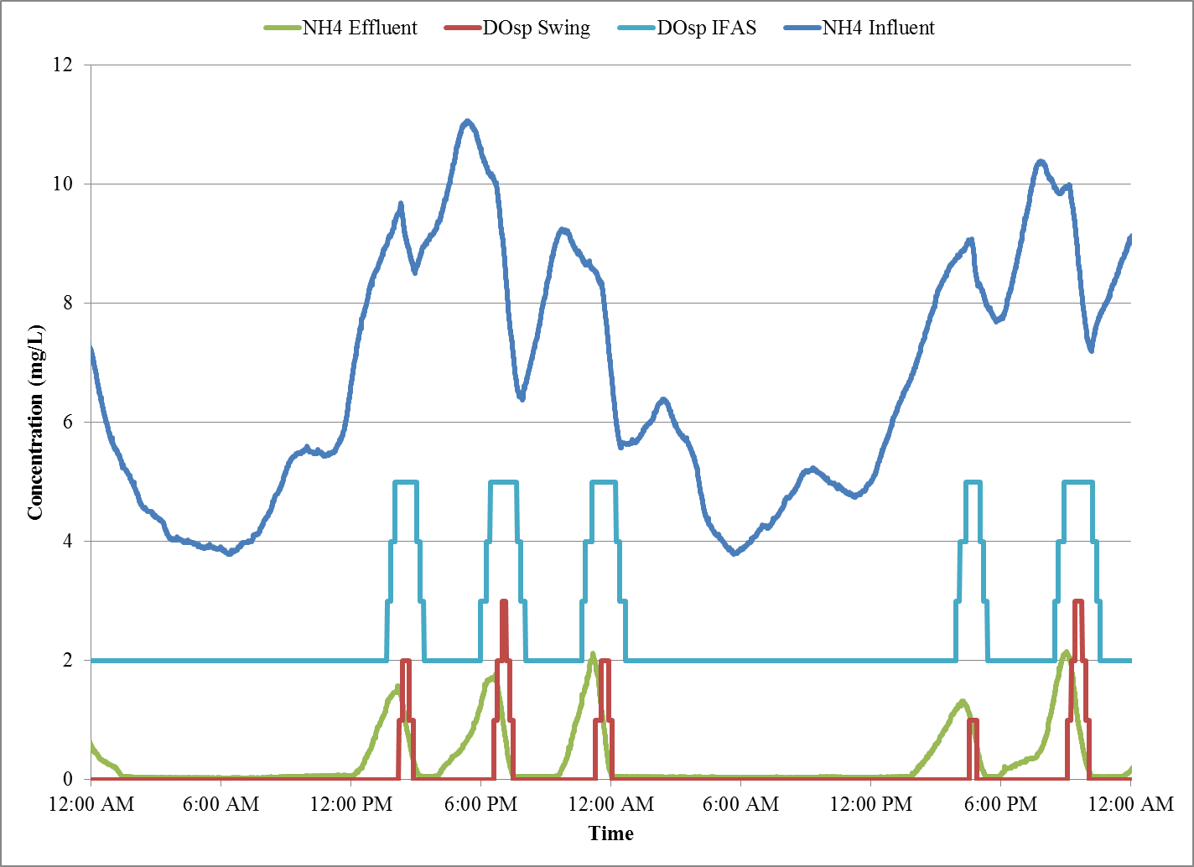
Figure 5: Swing Zone Control
The identical two representative days are again shown in Figure 6, this time demonstrating the header pressure control. As shown in this figure, the control system maintains a low pressure, approximately 6.75 psi, when the swing zones are in an anoxic state. This is due to the use of only coarse bubble diffusers for aeration in the IFAS zones. When the swing zones are switched to an aerobic state, the fine bubble diffusers in those zones become active, requiring an increase in the header pressure to approximately 7.55 psi. When the swing zones are again switched back to anoxic state, the pressure returns to the previous 6.75 psi level. As described previously, the system is estimated to save 15.5% when operating at the psi level. Between November 2014 and November 2015 it is estimated that the control system reduced the power consumption of the blowers by 9.34%. The system is able to control the blowers such that minimal disruption occurs in the aeration system.

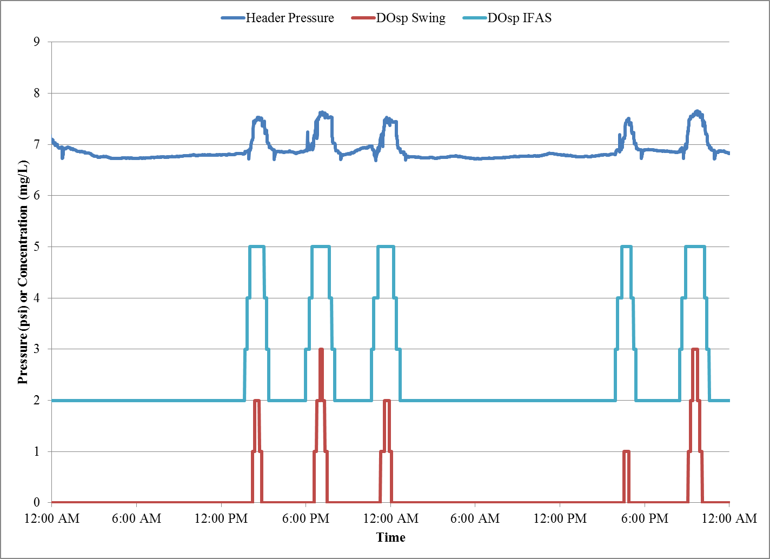
Figure 6: Aeration Header Pressure
The two representative days shown in Figure 5 and Figure 6 are also shown in Figure 7. Figure 7 demonstrates the tricking filter (TF) bypass and IMLR control for these two days. As shown in this figure, when the nitrate is low, the control system raises the IMLR flow to maximize the return of nitrates to the pre-anoxic zone, maximizing the denitrification performance of the process. When the nitrates remain low and the IMLR rate is at its maximum, the control system lowers the trickling filter bypass flow rate. This increases the influent flow that is sent to the trickling filters and reduces the flow that bypasses the trickling filter, reducing the amount of carbon , in the form of influent BOD, that is sent directly to the activated sludge/IFAS process.

Later, when the nitrate increases, the control system lowers the IMLR flow to avoid overloading the anoxic zones and wasting IMLR pump energy. Once the IMLR flow has reached its minimum value, the control system increases the trickling filter bypass flow to supply more carbon to the anoxic zones, increasing the denitrification rate, which will decrease the nitrate. In this manner the system balances the nitrate loading, carbon loading, and contact time to maximize the denitrification while minimizing the IMLR pump rate and the amount of excess carbon that enters the IFAS zones.

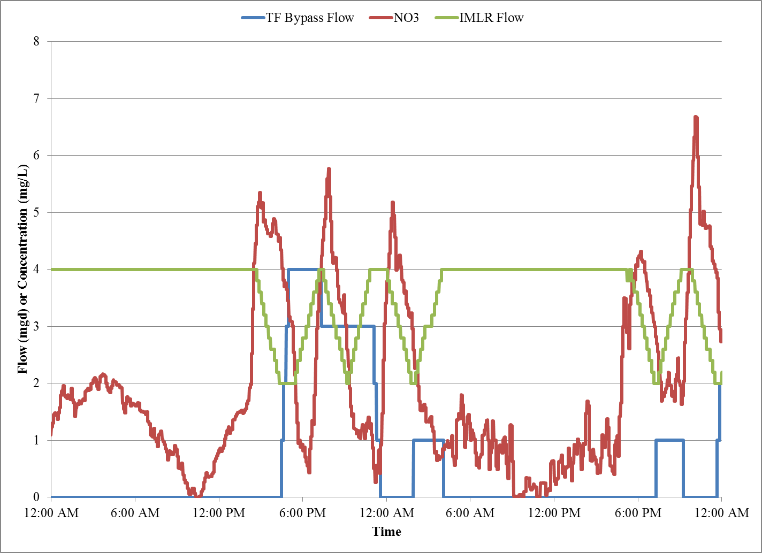
Figure 7: Trickling Filter Bypass and IMLR Control
SUMMARY & CONCLUSIONS

The control system integrates aeration control, ammonia control, and dentrification control into a single package that controls the effluent TN while minimizing the process energy consumption. The aeration intensity in the swing zones and IFAS zones is based upon the real time ammonia loading to the process, while the trickling fiter bypass and IMLR rates are varied to maximize dentrification in the anoxic zones, reducing the amount of methanol that would otherwise need to be added to the tertiary dentrification filter to achieve the effluent TN targets.
The aeration blowers are controlled on a total airflow basis, as opposed to a constant pressure basis. Combined with a most open valve control strategy, the blowers operate at the lowest possible pressure that will supply the required amount of airflow. This becomes especially important considering the combination of fine and coarse bubble diffusers on the same header and the large changes in pressure that occur when the fine bubble diffusers are switched on and off.
The control system employed at the COLA WWTP has allowed the plant to efficiently meet its permit requirements while overcoming challenges of to the process that was requried to fit within the plant footprint. The plant discharged a total of 65,471 pounds of nitrogen over its most recent reporting year versus a limit of 146,000 pounds.
REFERENCES
Åmand, L., Olsson, G., & Carlsson, B. (2013). Aeration control–a review. Water Science and Technology, 67(11), 2374-2398.
Kestel, S., Duffy, G. J., Gray, M., Stahl, T., & Lee, G. (2009). DO Control Based on On-line Ammonia Measurement. Proceedings of the Water Environment Federation, 2009(4), 473-488.
Leber, R., Kestel, S., Gray, M., & Duffy, G. (2009). Utilizing Automatic Dissolved Oxygen and Internal Recycle Set-Point Control at Abington WWTP in Southeastern Pennsylvania. Proceedings of the Water Environment Federation, 2009(17), 430-439.
Liu, W., Lee, G. J., Schloth, P. E., & Serra, M. E. (2005). Side by side comparison demonstrated a 36% increase of nitrogen removal and 19% reduction of aeration requirements using a feed forward online optimization system. Proceedings of the Water Environment Federation, 2005(12), 3447-3455.
Rieger, L., Jones, R. M., Dold, P. L., & Bott, C. B. (2014). Ammonia-based feedforward and feedback aeration control in activated sludge processes. Water Environment Research, 86(1), 63-73.
Shi, W., Wei, H., Li, B., Zhang, X., Lu, Y., Zhang, Q., ... & Kestel, S. (2014). Implementing an Aeration Control System at the Biggest WWTP in China. Proceedings of the Water Environment Federation, 2014(9), 5701-5711.

